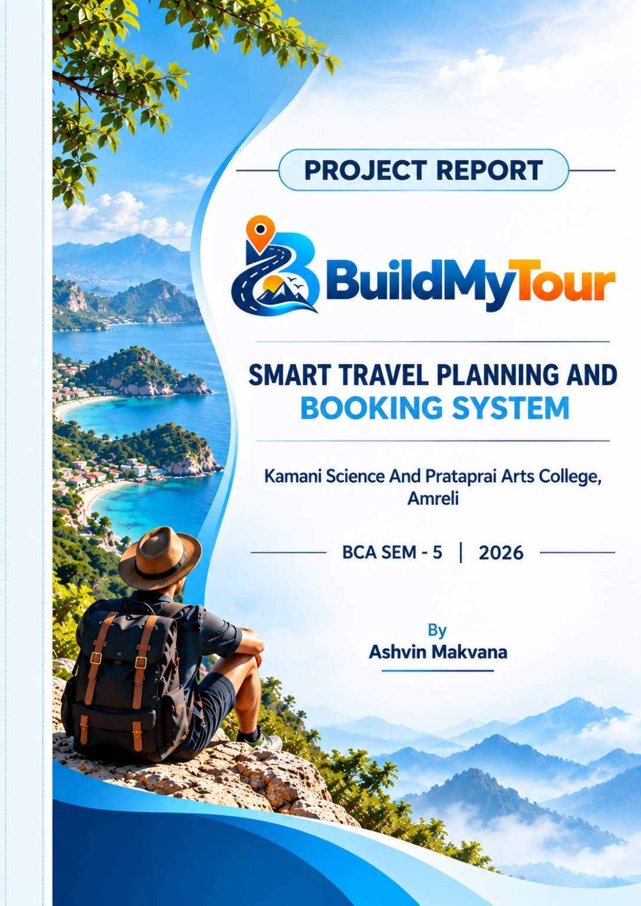
A PROJECT REPORT ON
"Smart Travel Planning and Booking System"
BuildMyTour
Kamani Science & Prataprai Arts College, Amreli
Developed By
Ashvin Makvana (Roll No - ______)
Guided By
Mr. Rakesh Sir Savaliya
Mr. Ravi Sir Joshi
Submitted in partial fulfillment of the requirement for
the award of the degree of Bachelor of Computer Application (BCA)
BCA SEM - 5 | 2026 - 2027
Saurashtra University - Rajkot

INDEX

No. | Title | Page No.
1 | Preface | 5
2 | Acknowledgement | 6
3 | Abstract | 7
4 | Introduction | 8
5 | Time Line Chart | 9
6 | Project Profile | 10
7 | Hardware Requirement | 11
8 | Software Requirement | 12
9 | Requirement Specification | 13
10 | Problem Definition | 14
11 | Project Planning & Scheduling | 15
12 | System Analysis | 16
13 | Feasibility Study | 17-18
14 | Project Page Structure | 19
15 | Data Dictionary | 20-24
16 | Data Flow Diagram | 25
17 | Context & First Level Diagram | 26-27
18 | ER Diagram | 28
19 | Use Case Diagram | 29
20 | Activity Diagrams | 30-32
21 | Screenshots (Page UI) | 33-35

Preface
The main objective of a computer science student is to gain practical knowledge along with theoretical knowledge. Developing a project provides valuable experience in understanding how software concepts are applied in a real-world application.
Through the development of BuildMyTour – Smart Travel Planning and Booking System, we gained practical experience in web development, database management, user authentication, trip planning, booking management and software testing.
BuildMyTour is designed to provide a simple and organized platform for planning tours according to trip requirements such as trip type, travel date, duration, number of travelers and budget. The system generates a suitable tour plan and provides a structured booking workflow.
During the development of this project, we learned about different strategies and software engineering concepts that can be applied while designing and developing a web-based system. This project has provided useful practical knowledge and experience for our future career.
We are pleased to present this project report. Proper care has been taken while organizing the report so that the information is easy to understand. The report describes the analysis, design, development, database, testing and major features of the BuildMyTour system.
Acknowledgement
I am a student of BCA Sem-5 studying in the Kamani Science & Prataprai Arts College, Amreli. I would like to thank all the people who have given their support in shaping the BuildMyTour – Smart Travel Planning and Booking System.
I thank Mr. Rakesh Sir Savaliya and Mr. Ravi Sir Joshi for giving me guidance and co-operation in understanding the system. I also thank them for their unconditional help in making this project.
I have a great deal of gratitude towards our Head of Department who encourages taking up this activity. I thank all faculties and administrative staff of the institute.
I am also thankful to all those friends who have helped me in this endeavor either directly or indirectly, and especially my family.
Thanks to all!!
Ashvin Makvana
Abstract
BuildMyTour – Smart Travel Planning and Booking System is a web portal developed to help users plan and book tours in a simple and organized way. The system provides a Smart Trip Planner through which users can select their trip type, start date, duration, number of travelers and budget. Based on these details, the system matches suitable tour packages and generates a travel plan.
The project provides facilities for user registration and login, trip planning, package selection, checkout, booking confirmation, viewing bookings and submitting reviews. The system also provides an Admin section where the administrator can manage users, trip types, tour packages, bookings and reviews.
BuildMyTour is developed as a web-based academic project using HTML5, CSS3, JavaScript and Bootstrap for the front end, PHP for the back end and MySQL/MariaDB for database management. XAMPP is used as the local development environment. The system stores generated trip plans and booking information in the database and provides a structured platform for managing travel planning and booking activities.
Introduction
Travel planning often requires users to collect information about destinations, tour packages, travel duration, budget and booking details from different sources. Managing these activities manually can make the planning process time-consuming and less organized. To address this requirement, BuildMyTour – Smart Travel Planning and Booking System is developed as a web-based travel planning and booking system.
BuildMyTour provides a simple platform where users can register and login, enter their travel requirements and use the Smart Trip Planner to find suitable tour packages. The planner considers details such as trip type, start date, duration, number of travelers and budget. Based on the selected requirements, the system matches available tour packages and generates a travel plan for the user.
The system has two main sections, namely User and Admin. In the User section, users can plan a trip, view the generated plan, select a suitable package, complete the checkout process, view their bookings and submit reviews. In the Admin section, the administrator can manage users, trip types, tour packages, bookings and reviews.
The project is developed using HTML5, CSS3, JavaScript and Bootstrap for the front end, PHP for the back end and MySQL/MariaDB for database management. XAMPP is used as the local development environment. The system provides an organized approach to travel planning and booking while keeping the implementation simple and suitable for an academic project.
Time Line Chart
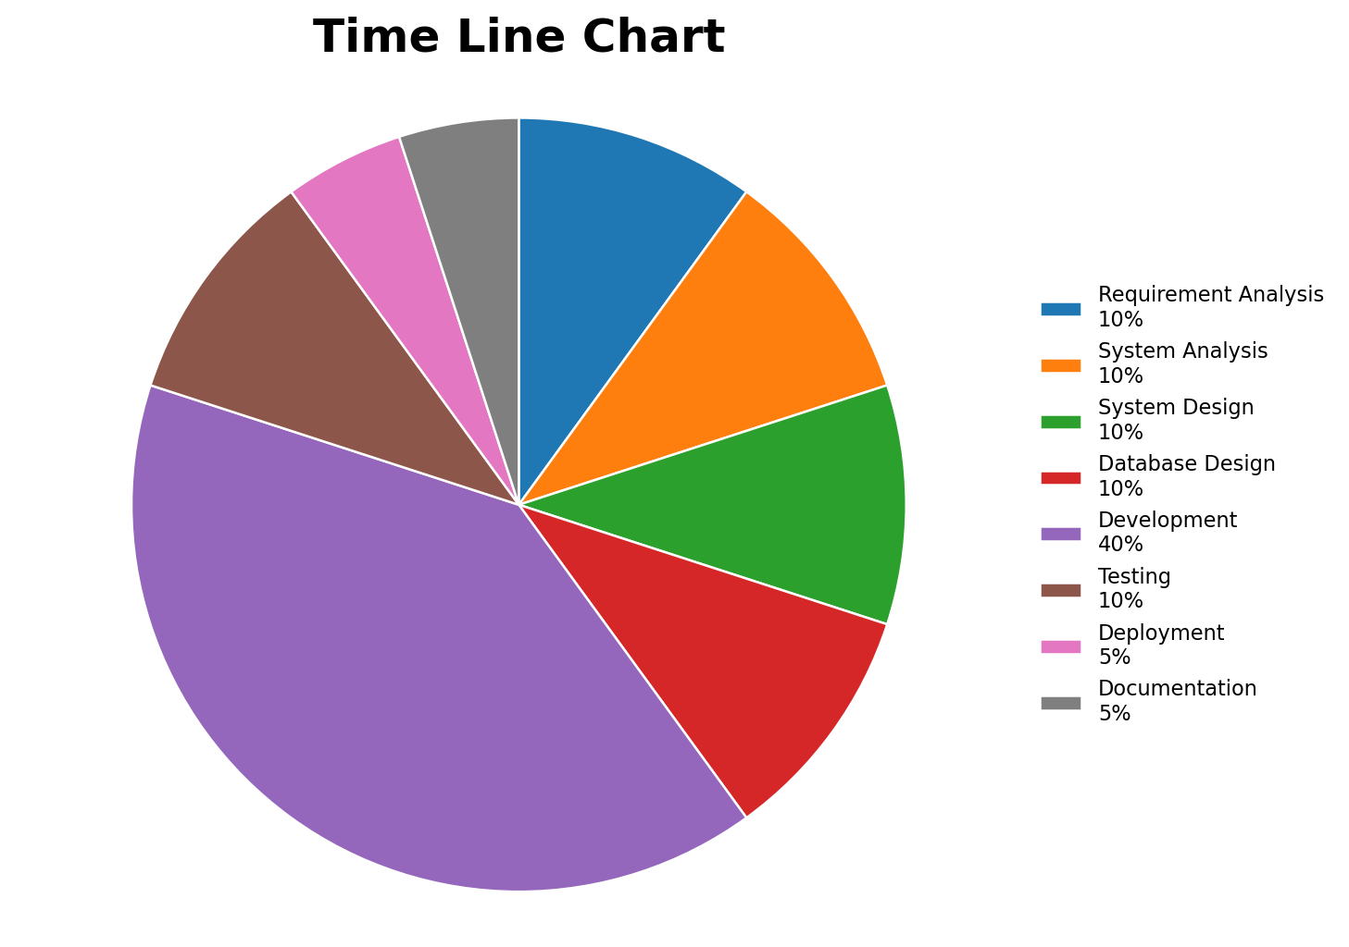
Activity |  | Duration
Requirement Analysis | → | 10 Days
System Analysis | → | 10 Days
System Design | → | 10 Days
Database Design | → | 10 Days
Development | → | 40 Days
Testing | → | 10 Days
Deployment | → | 5 Days
Documentation | → | 5 Days
Project Profile
Project Name | Smart Travel Planning and Booking System
Website Name | BuildMyTour
Developed By | Ashvin Makvana
Front End Tools | HTML5, CSS3, JavaScript, Bootstrap 5.3
Back End Tools | PHP 8+ (Core PHP), MySQL / MariaDB
Local Server | XAMPP (Apache + MySQL / MariaDB)
Computer System | Computer / Laptop suitable for local web development
Project Details | Provides a platform for users to plan trips, find suitable tour packages, generate a travel plan according to trip requirements, make bookings and submit reviews. The Admin section is used to manage users, trip types, tour packages, bookings and reviews.
Completion Time | 100 Days
Guided By | Mr. Rakesh Sir Savaliya & Mr. Ravi Sir Joshi
University | Saurashtra University, Rajkot
Hardware Requirement
• Computer / Laptop
• Minimum 4 GB RAM
• Intel Core i3 processor or equivalent
• Keyboard and Mouse
• Monitor / Display
• Internet / Network connection
Software Requirement
• Operating System : Microsoft Windows
• Front End Tools : HTML5, CSS3, JavaScript, Bootstrap 5.3
• Back End Tool : PHP 8+ (Core PHP)
• Database : MySQL / MariaDB
• Local Server : XAMPP (Apache + MySQL / MariaDB)
• Code Editor : Visual Studio Code or similar editor
• Browser Specification : Google Chrome, Mozilla Firefox or Microsoft Edge
• Documentation Tool : Microsoft Word
Requirement Specification
This section provides a requirement overview of the system.
• Registration : User must be registered in the system to use the important functionality of BuildMyTour. Unregistered users cannot create a trip or make a booking.
• Login : User can login to the system by entering a valid email and password to use the protected functionality of the system.
• Smart Trip Planner : User can enter trip type, start date, duration, number of travelers and budget. The system uses these details to find suitable tour packages and generate a travel plan.
• Tour Package : User can view available tour packages and their details and select a suitable package according to the trip requirements.
• Booking : User can proceed with a selected tour package, complete the checkout process and receive booking confirmation after a successful booking.
• My Bookings : User can view the details of previously created bookings from the My Bookings section.
• Review : User can submit a review for the booked tour package.
• Admin : Administrator can login and manage users, trip types, tour packages, bookings and reviews.
Project Problem Definition
• Maintain User Profile
• Maintain Trip Planning
• Maintain Trip Package Selection
• Maintain Booking
• Maintain Payment / Checkout
• Maintain Review and Rating
Project Planning & Scheduling
Project planning is an aspect of project management, comprising various processes. The aim of these processes is to ensure that various project tasks are well coordinated and meet the project objectives, including timely completion of the project. The project plan reflects the current status of all project activities and is used to monitor and control the project.
The project planning tasks ensure that various elements of the project are coordinated and therefore guide the project execution. Project scheduling is one of the important tasks of project planning and helps in arranging the activities of the BuildMyTour project in a systematic sequence.
Project Planning & Scheduling as under:
• Preliminary Investigation
• Requirement Analysis
• System Analysis
• System Design
• Database Design
• Coding / Development
• Testing
• Implementation
• Documentation
System Analysis
System analysis is the process of identification of objectives and requirements, evaluation of alternative solutions and recommendation of the most feasible solution. In other words, system analysis is the step-by-step process of gathering, recording and interpreting facts. The main aim of analysis is to determine problem areas and to find solutions to reduce or eliminate them.
System analysis itself breaks into two stages: (1) Preliminary analysis, and (2) Detailed analysis.
During analysis, data is collected from the available files, decision points and transactions of the system using various tools such as the Data Flow Diagram (DFD).
For BuildMyTour, the analysis focuses on understanding user registration and login, trip planning, tour package selection, booking, reviews and the administrative functions required to manage the system.
Feasibility Study
The purpose of a feasibility study is to check the possibility of a computerized solution to the observed problem before much money and time are spent on it. A feasibility study is carried out to select the best system that meets performance requirements.
For BuildMyTour, the feasibility study is used to determine whether the proposed Smart Travel Planning and Booking System is practical with the available technology, operating resources and development cost.
There are three types of feasibility study: (1) Technical, (2) Operational, and (3) Economical.
Technical Feasibility
Technical feasibility considers whether the desired project can be completed within the framework of available technology. BuildMyTour is a web-based project developed using HTML5, CSS3, JavaScript, Bootstrap 5.3, PHP 8+ and MySQL/MariaDB with XAMPP. These technologies are available for development and testing of the system.
Operational Feasibility
Operational feasibility considers whether the developed product can be used effectively. BuildMyTour provides registration, login, smart trip planning, tour package selection, booking, reviews and administration functions. These features support the normal activities of users and administrators.
Economical Feasibility
Economical feasibility considers whether the project can be completed within reasonable cost. BuildMyTour uses commonly available development tools and software such as XAMPP, PHP, MySQL/MariaDB, Bootstrap and a web browser. Therefore, the required resources for this academic project are manageable.
Project Page Structure
The diagram below shows the navigation hierarchy of the BuildMyTour system across the Public Website, User Portal and Admin Portal.
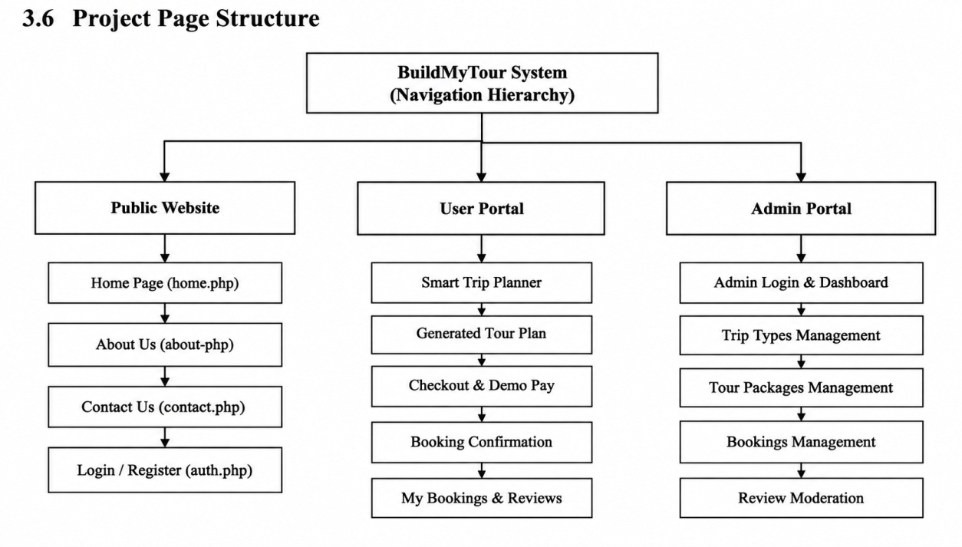
Data Dictionary
The data dictionary is a set of tables. MySQL uses it to maintain information about its own database. It contains the following information: the name of the database table, user information such as privileges, and the name and data type of all columns in the database table.
Database Name : buildmytour
1. admins
This table is used to store admin information.
Field | Data Type | Size | Attribute
id | Int | 11 | Primary Key
name | Varchar | 100 | -
email | Varchar | 150 | Unique
password | Varchar | 255 | -
status | Enum | active/inactive | -
created_at | Timestamp | - | -

2. users
This table is used to store user registration information.
Field | Data Type | Size | Attribute
id | Int | 11 | Primary Key
name | Varchar | 100 | -
email | Varchar | 150 | Unique
phone | Varchar | 20 | -
password | Varchar | 255 | -
created_at | Timestamp | - | -

3. trip_categories
This table is used to store trip category information.
Field | Data Type | Size | Attribute
id | Int | 11 | Primary Key
name | Varchar | 100 | Unique
description | Varchar | 255 | -
status | Enum | active/inactive | -

4. tour_packages
This table is used to store tour package information.
Field | Data Type | Size | Attribute
id | Int | 11 | Primary Key
category_id | Int | 11 | Foreign Key
title | Varchar | 150 | -
description | Text | - | -
destination | Varchar | 100 | -
duration_days | Int | 11 | -
price | Decimal | 10,2 | -
image_destination | Varchar | 255 | -
image_transport | Varchar | 255 | -
image_hotel | Varchar | 255 | -
image_meal | Varchar | 255 | -
status | Enum | active/inactive | -

5. trips
This table is used to store generated trip plan information.
Field | Data Type | Size | Attribute
id | Int | 11 | Primary Key
user_id | Int | 11 | Foreign Key
trip_type_id | Int | 11 | Foreign Key
start_date | Date | - | -
duration_days | Int | 11 | -
travelers | Int | 11 | -
budget | Decimal | 10,2 | -
generated_plan_json | LongText | - | -
created_at | Timestamp | - | -

6. bookings
This table is used to store booking information.
Field | Data Type | Size | Attribute
id | Int | 11 | Primary Key
user_id | Int | 11 | Foreign Key
trip_id | Int | 11 | Foreign Key
package_id | Int | 11 | Foreign Key
travelers | Int | 11 | -
total_amount | Decimal | 10,2 | -
payment_method | Varchar | 50 | -
payment_status | Varchar | 30 | -
booking_status | Varchar | 30 | -
booking_reference | Varchar | 50 | Unique
created_at | Timestamp | - | -

7. reviews
This table is used to store user review and rating information.
Field | Data Type | Size | Attribute
id | Int | 11 | Primary Key
user_id | Int | 11 | Foreign Key
package_id | Int | 11 | Foreign Key
rating | Int | 11 | -
review | Text | - | -
status | Enum | active/inactive | -
created_at | Timestamp | - | -

The above tables together maintain the main data required for users, administrators, trip categories, tour packages, generated trips, bookings and reviews in the BuildMyTour system.
Data Flow Diagram
The DFD gives a brief idea of how the designed system works. It also indicates the type of users who use the system and the processes involved in the system.
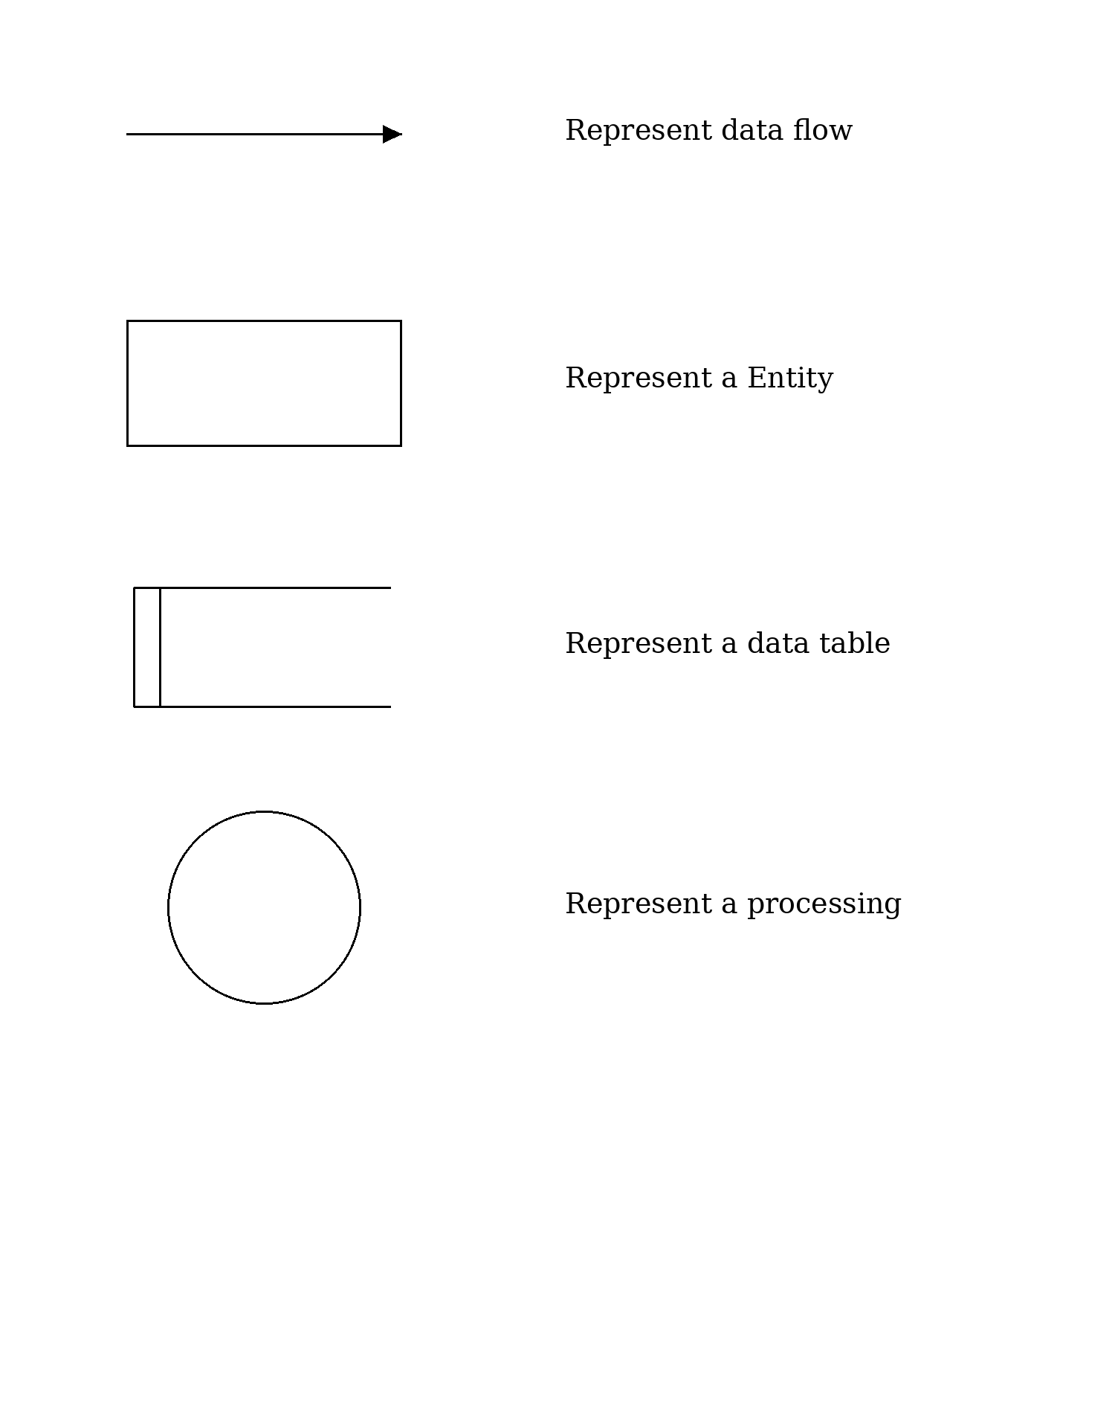
Context Level Diagram
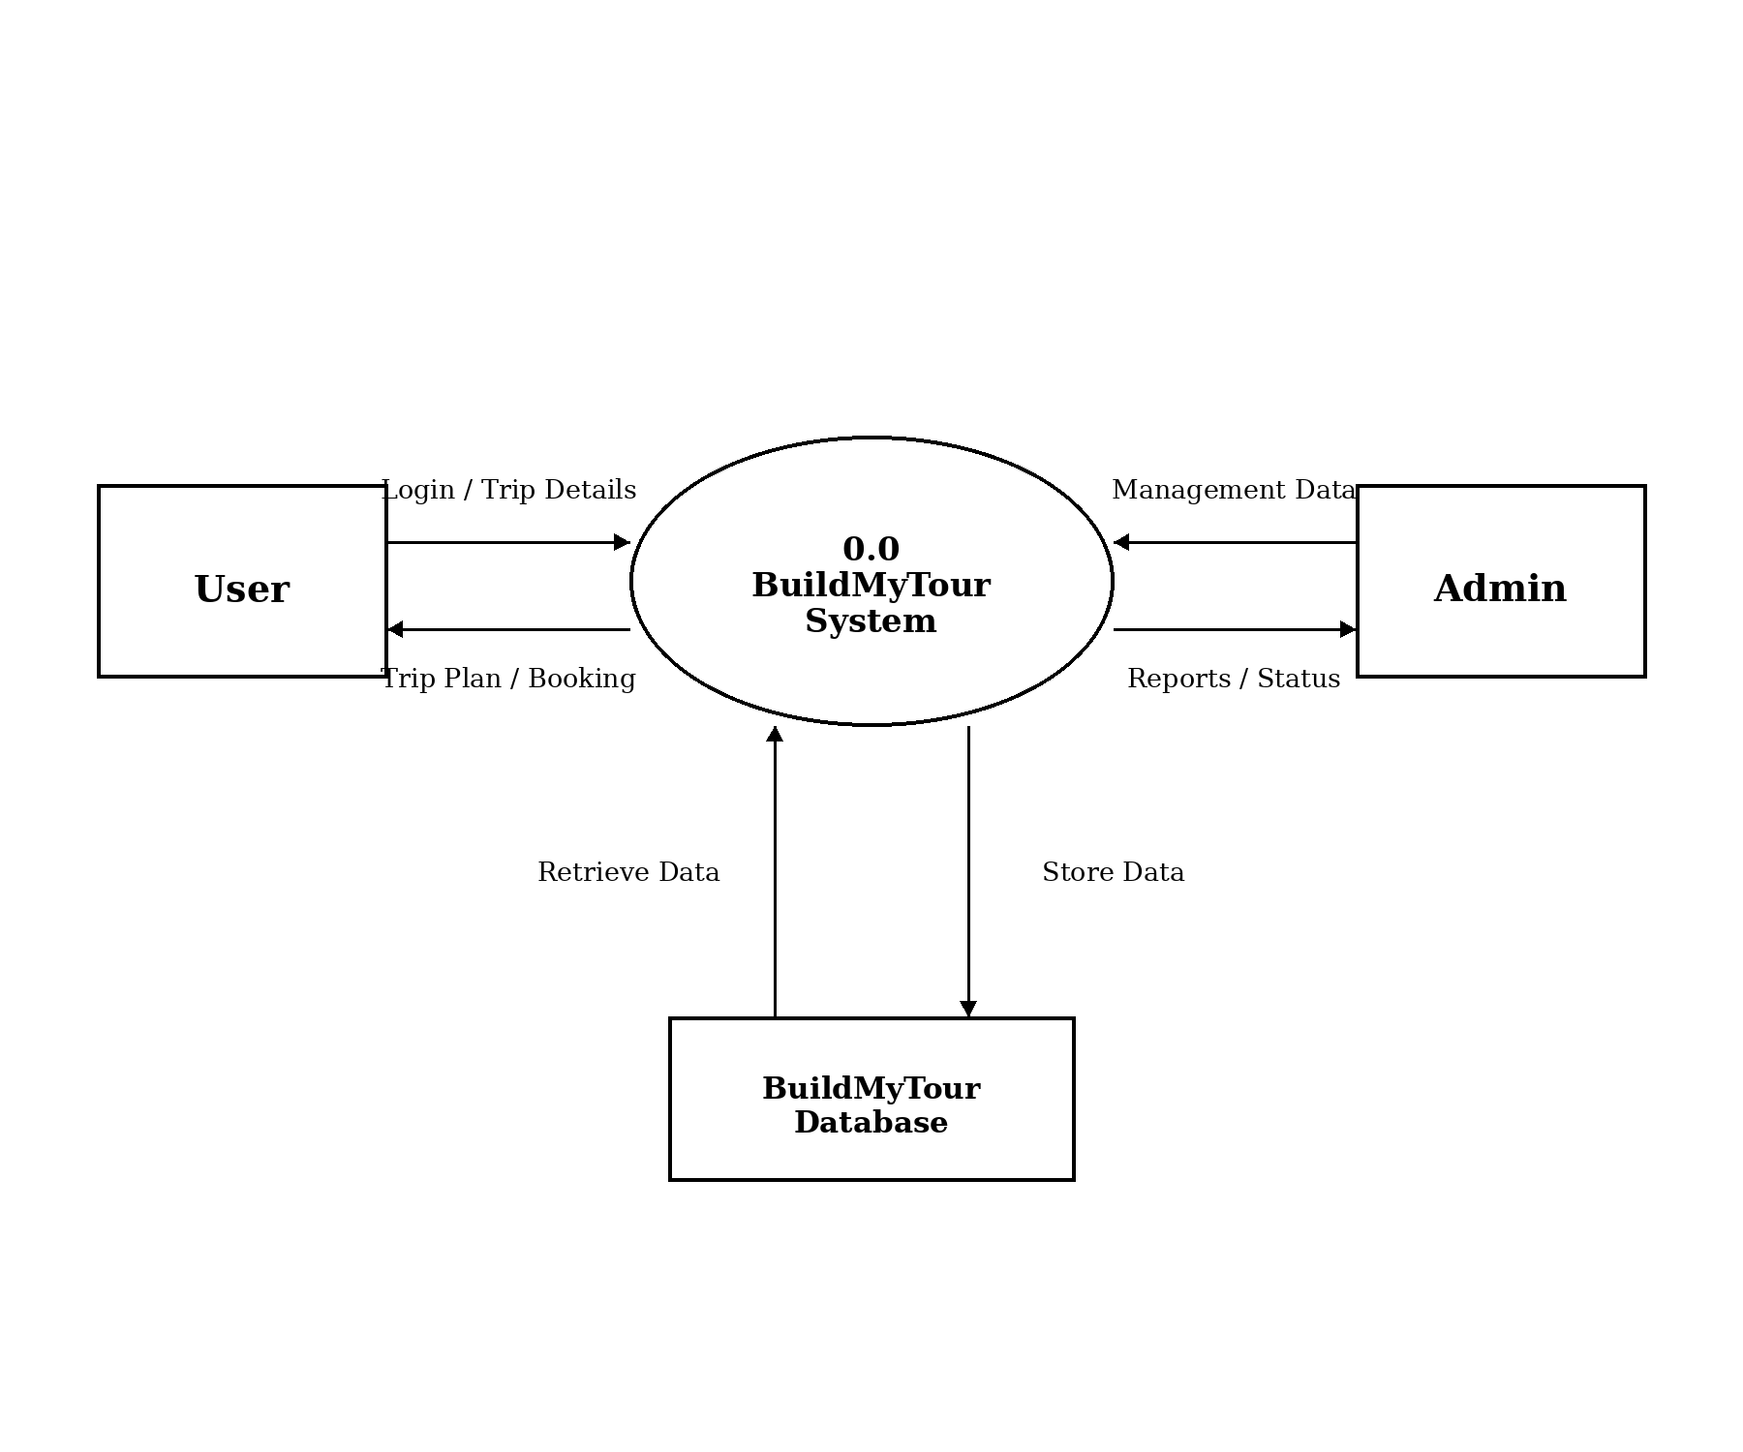
First Level Diagram
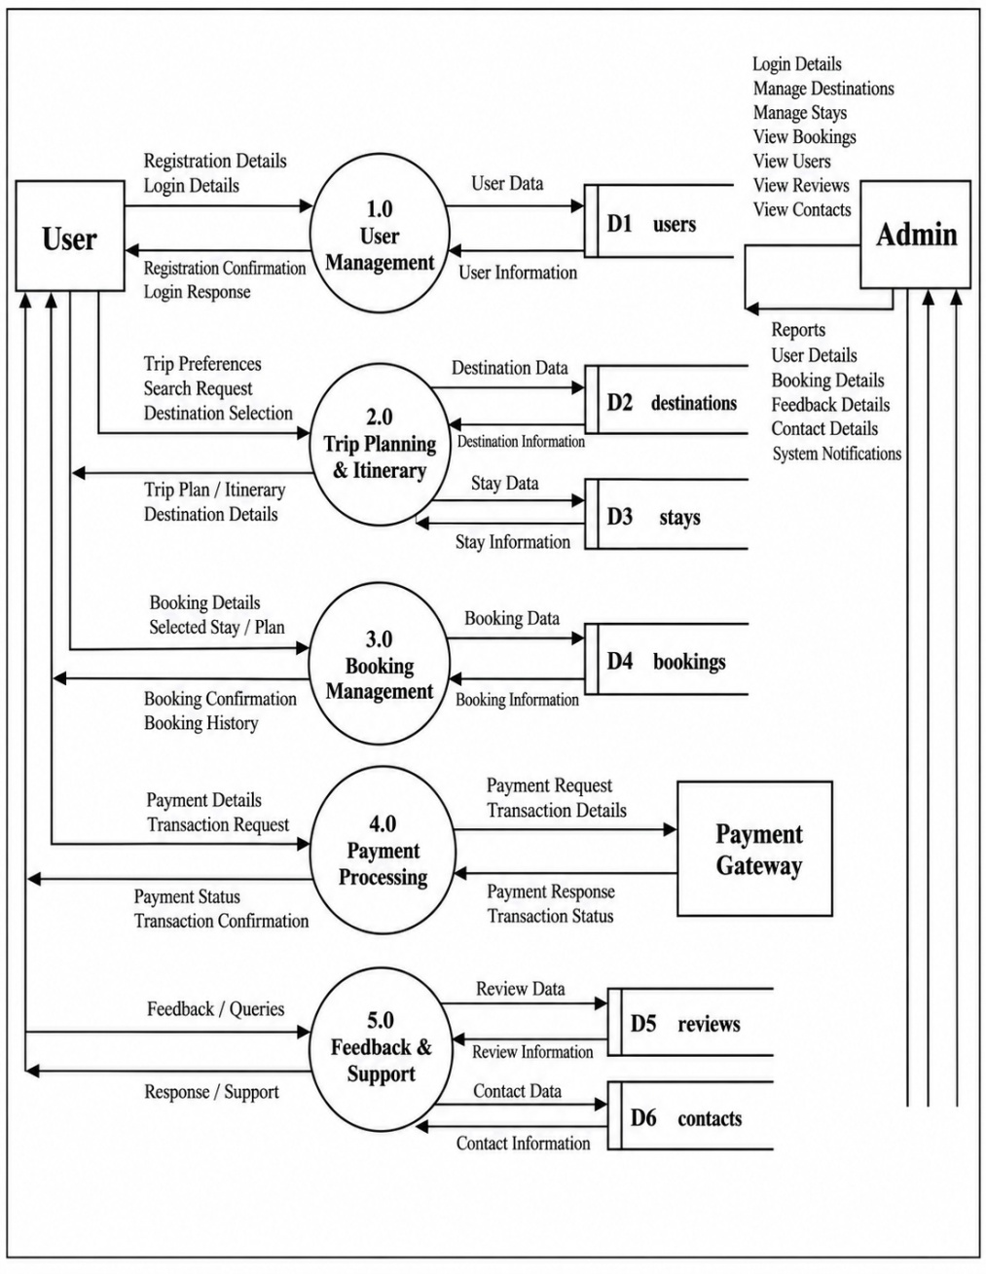
ER Diagram
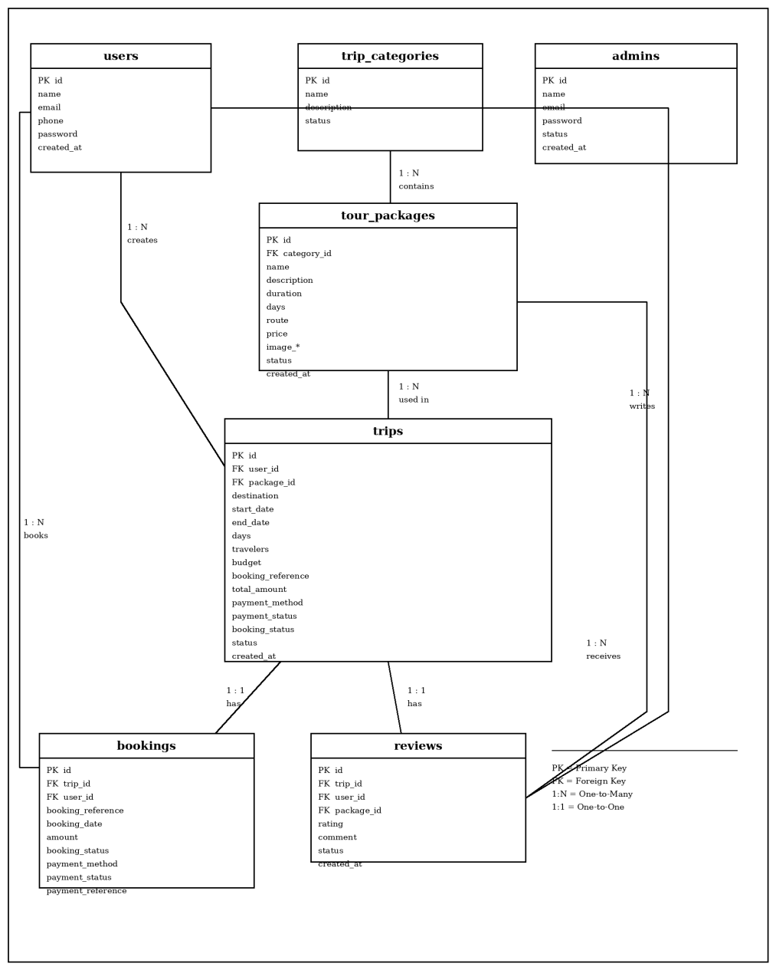
Use Case Diagram
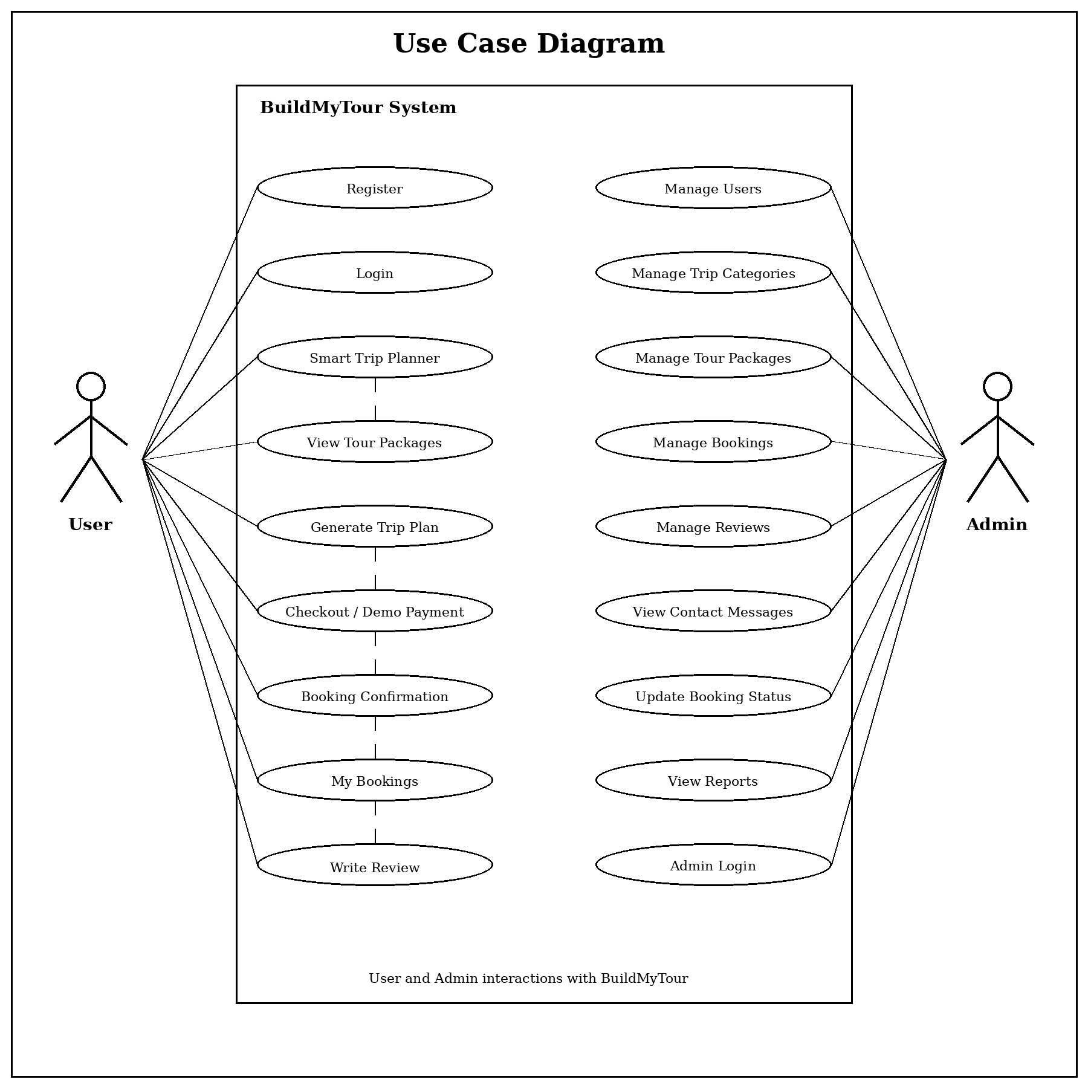
Activity Diagram – User Side
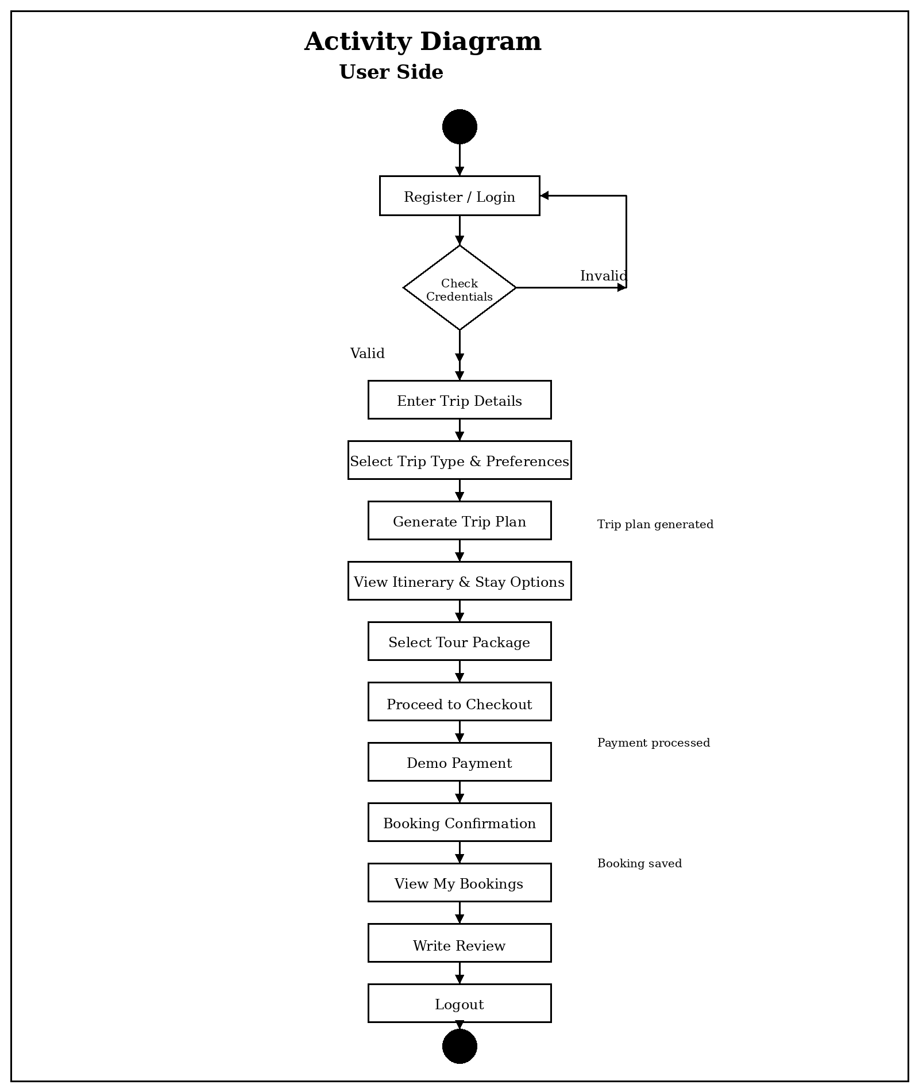
Activity Diagram – Admin Side
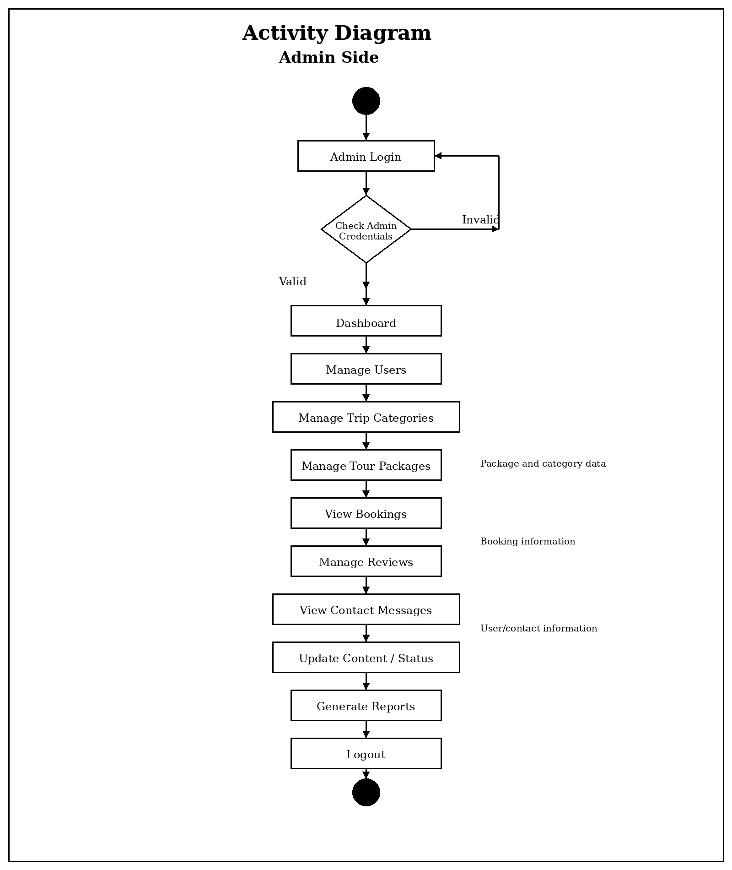
Activity Diagram – Booking & Payment Flow
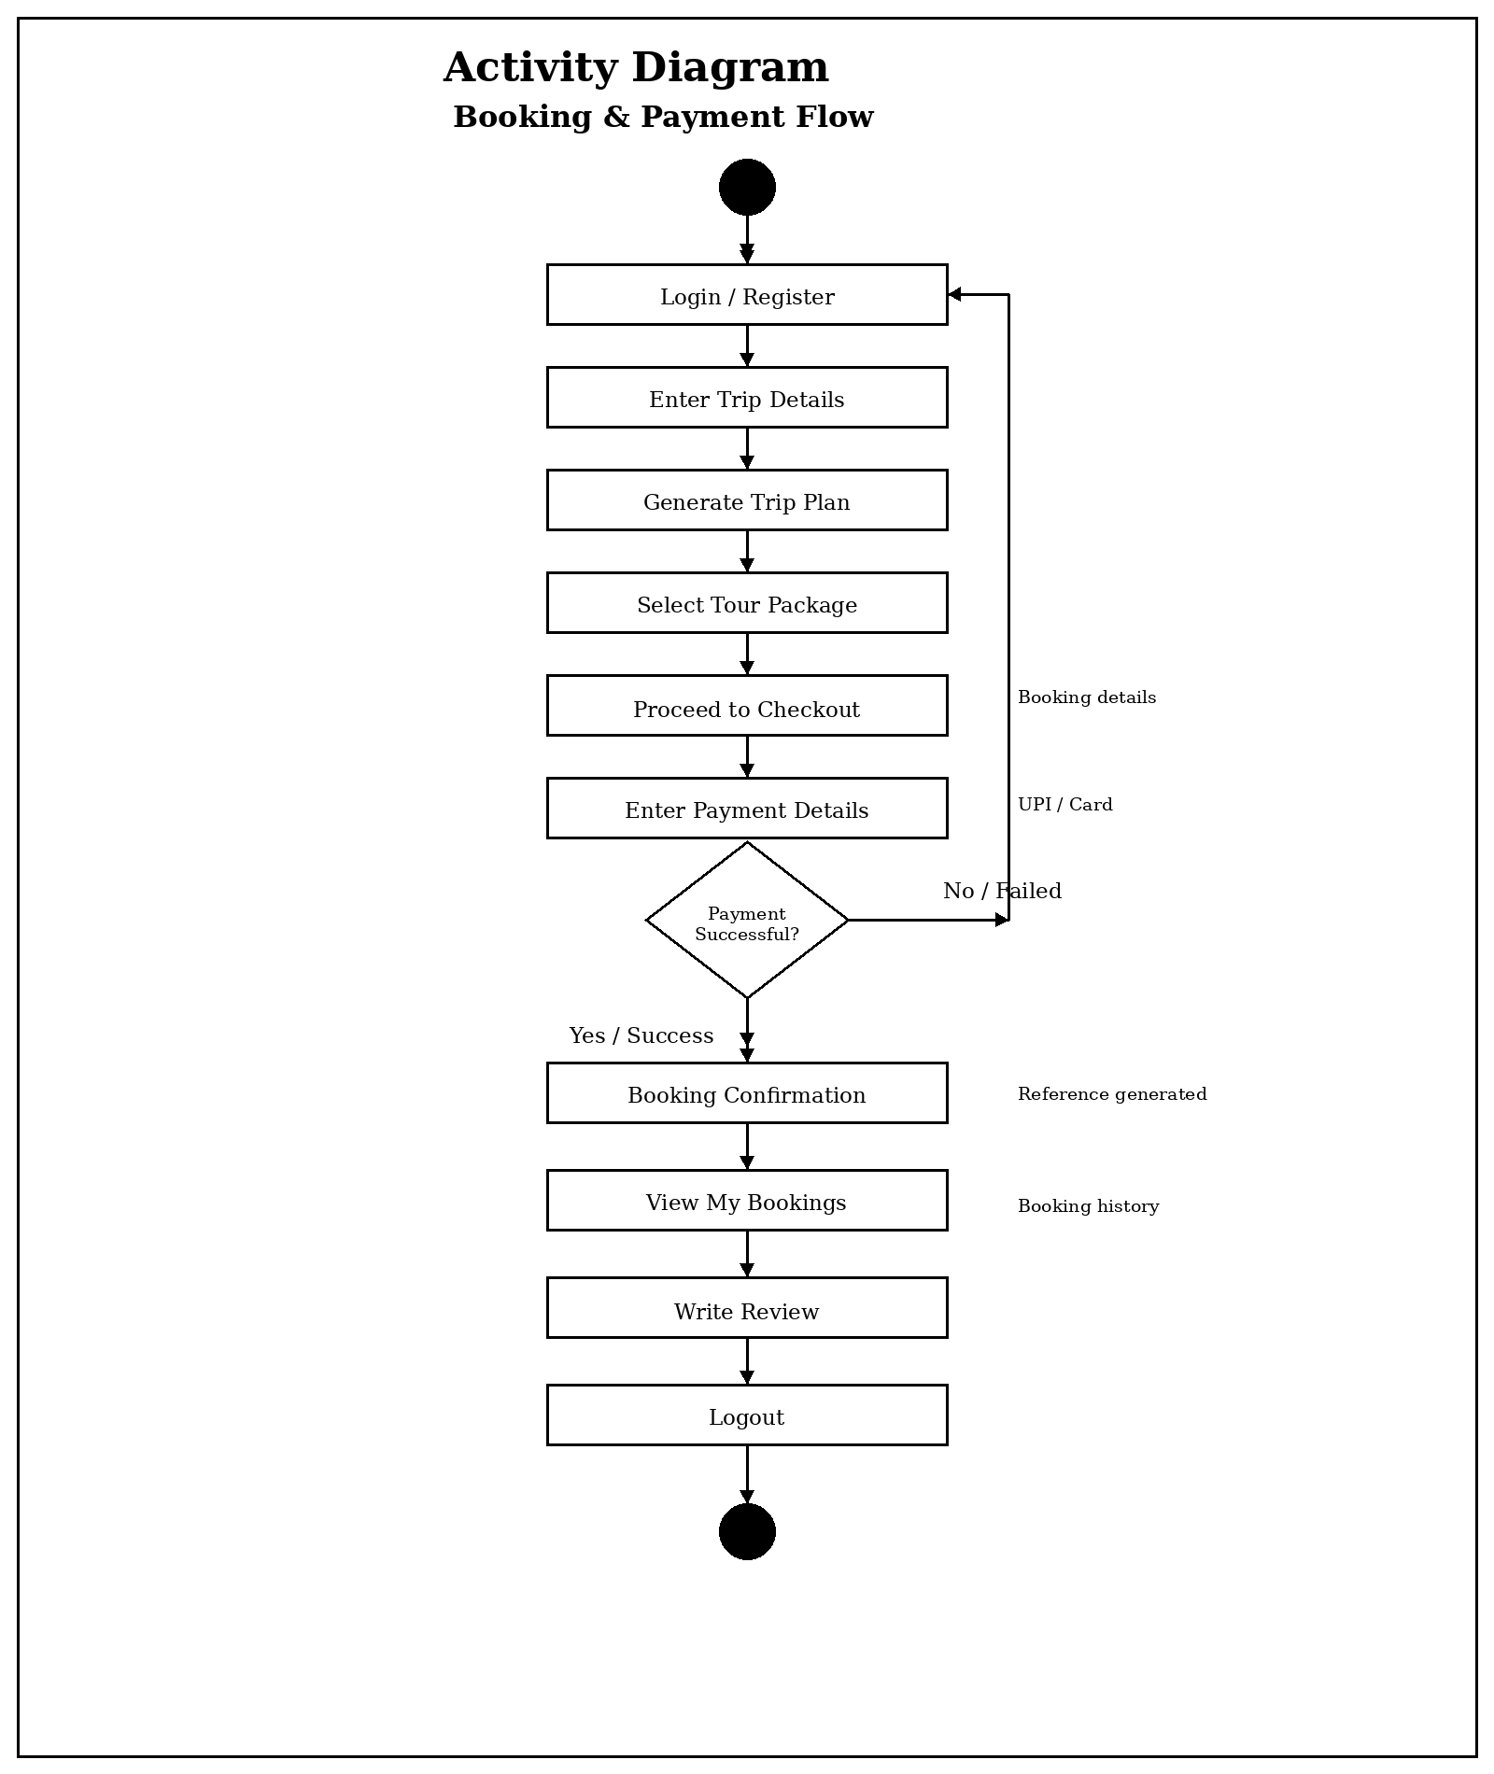
Screen Shots
The screenshots in this section will be captured from the live BuildMyTour application and inserted here. Placeholders are provided below for each screen; replace each placeholder with the actual captured screenshot.
Figure 1: BuildMyTour – Home Page
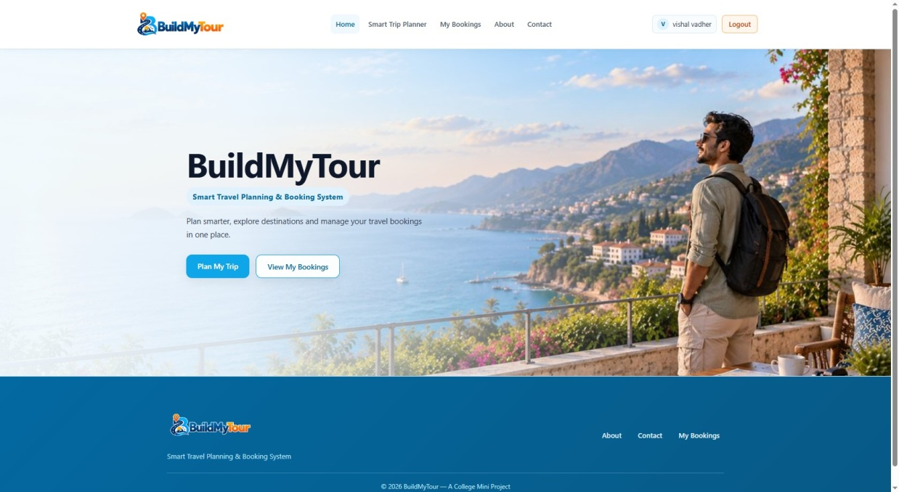

Figure 2: BuildMyTour – About
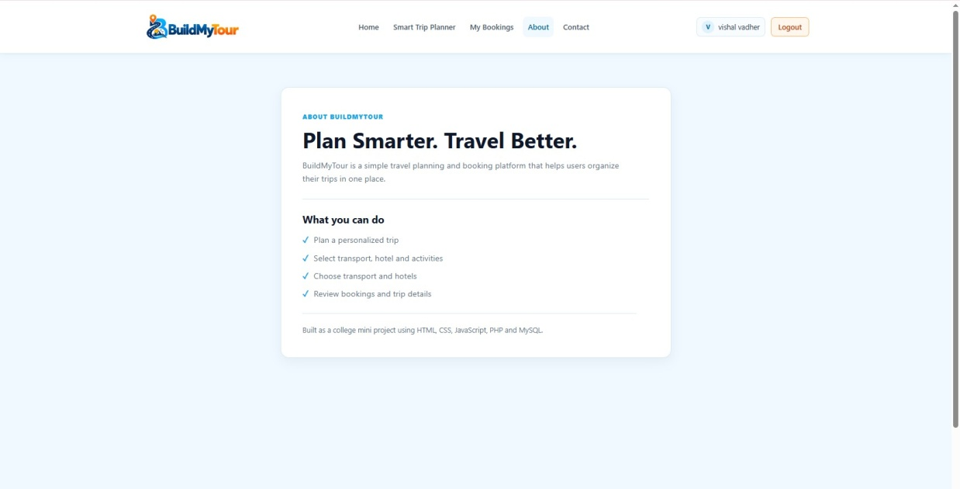

Figure 3: BuildMyTour – Contact
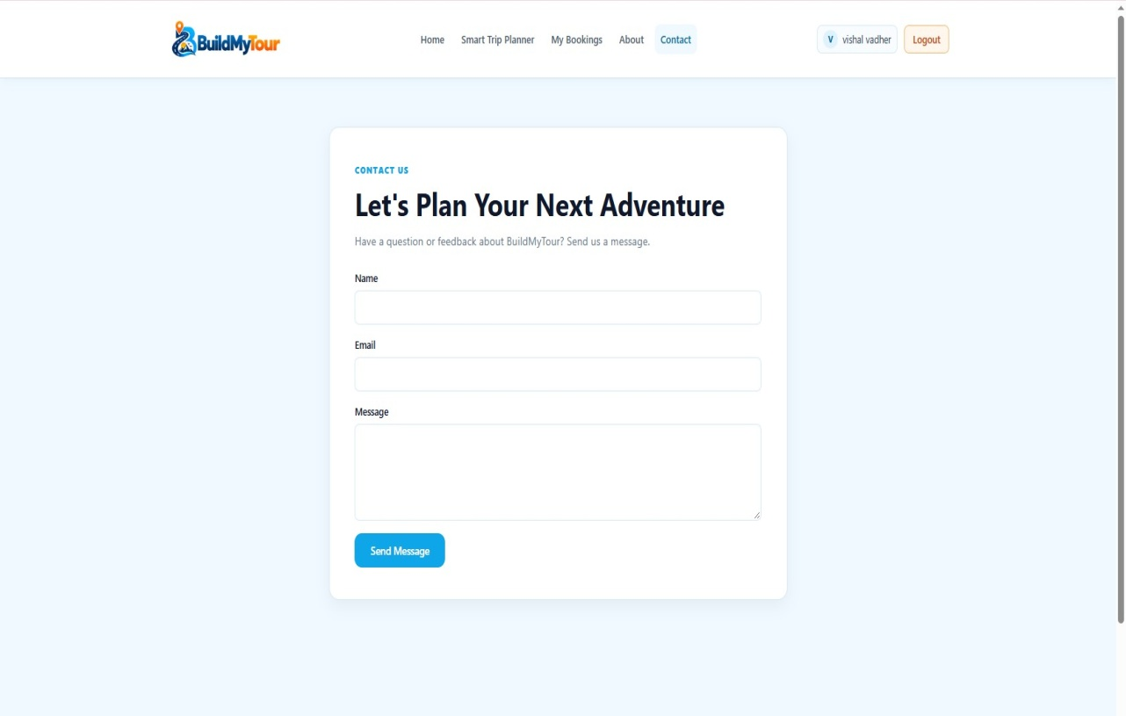

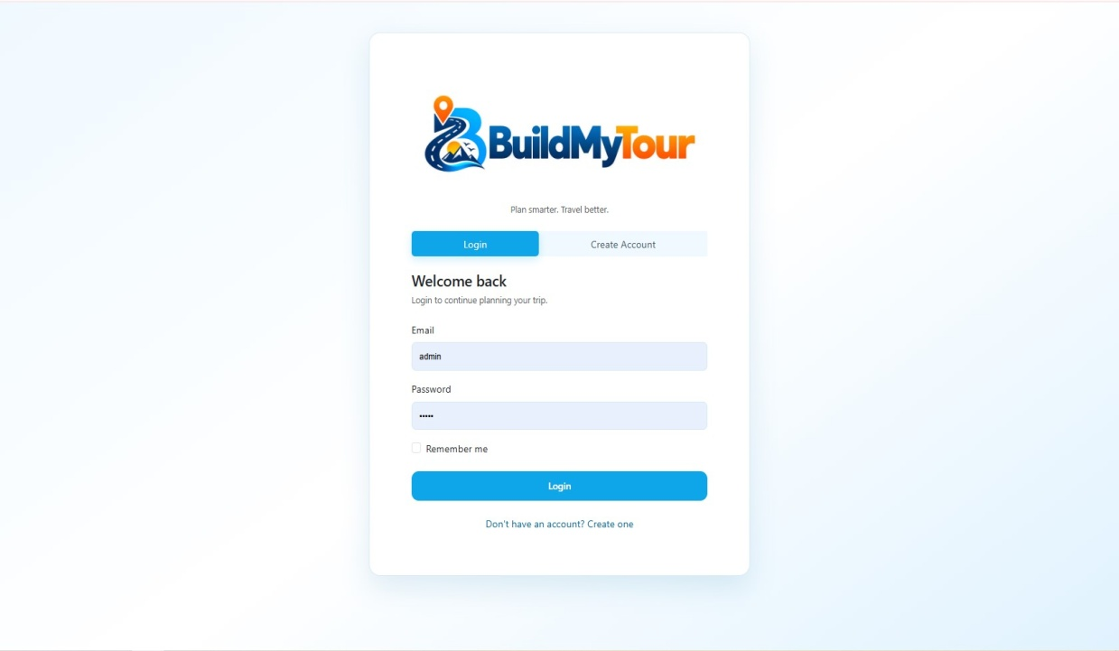
Figure 4: BuildMyTour – Login

Figure 5: BuildMyTour – Registration
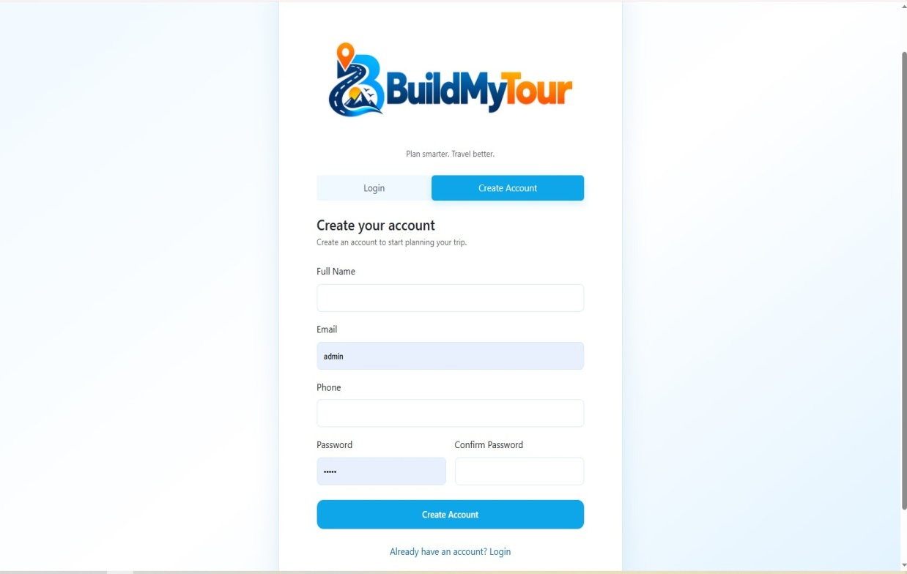

Figure 6: BuildMyTour – Smart Trip Planner
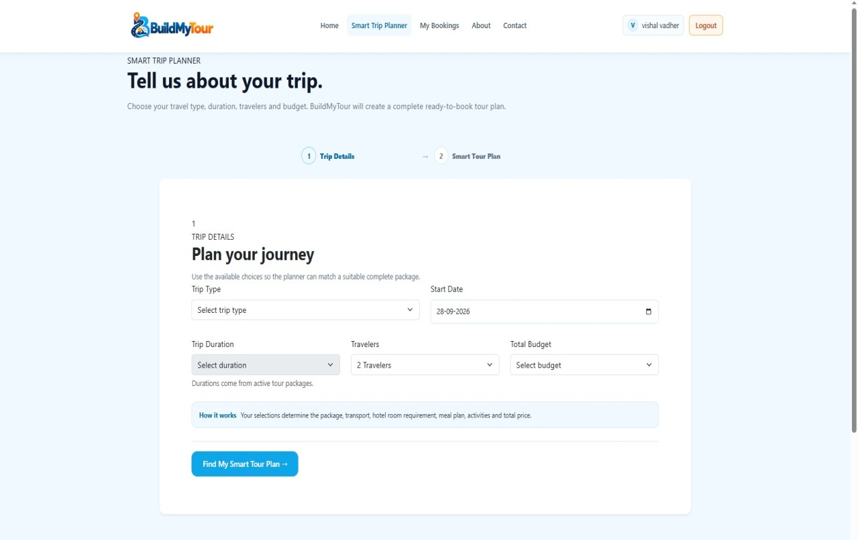

Figure 8: BuildMyTour – Generated Tour Package
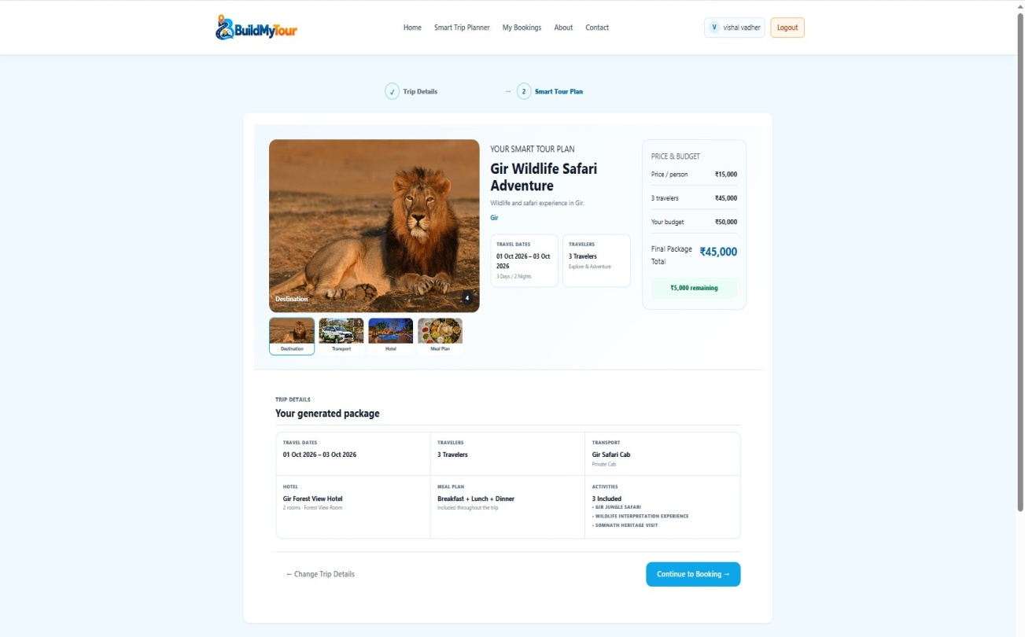

Figure 12: BuildMyTour – Checkout & Payment
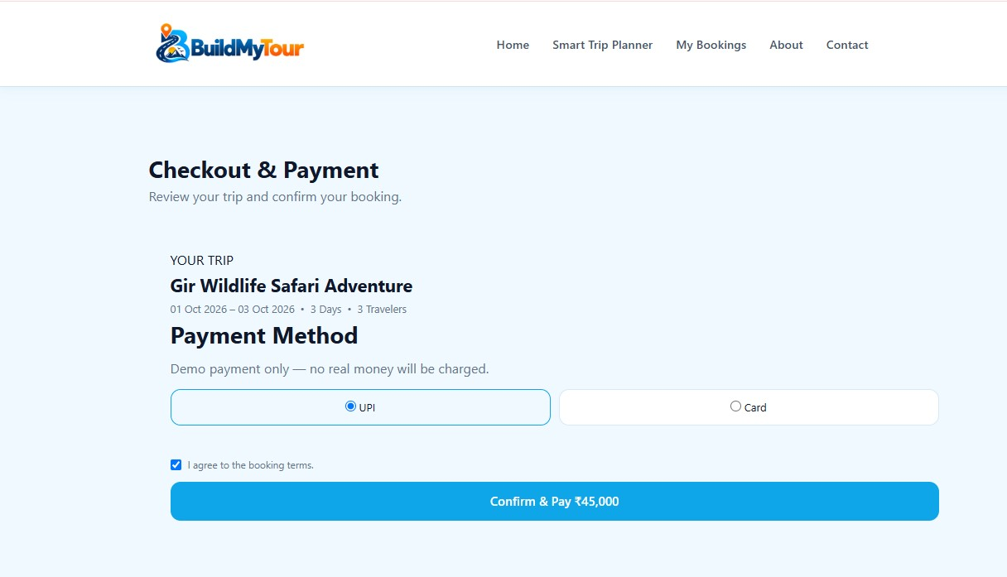

Figure 14: BuildMyTour – Booking Confirmation
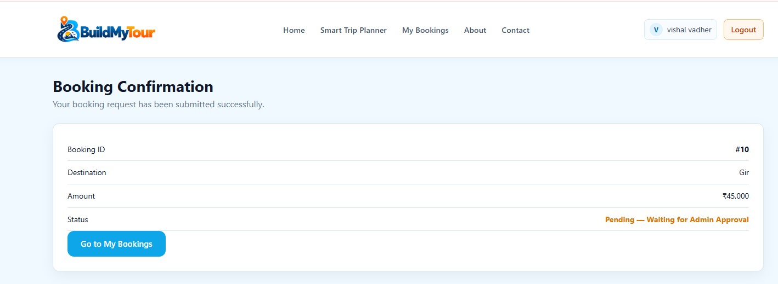

Figure 15: BuildMyTour – My Bookings
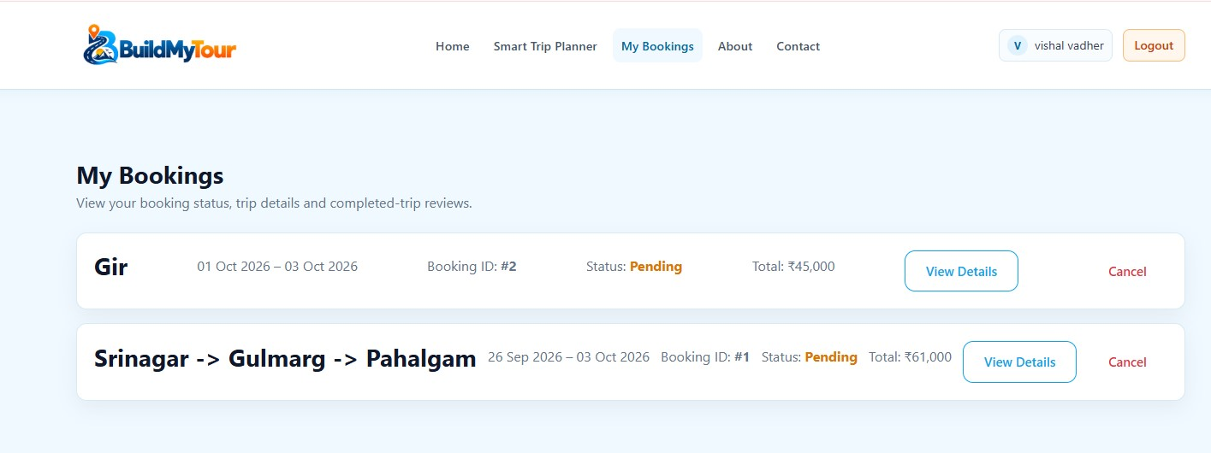

Figure 16: BuildMyTour – Reviews
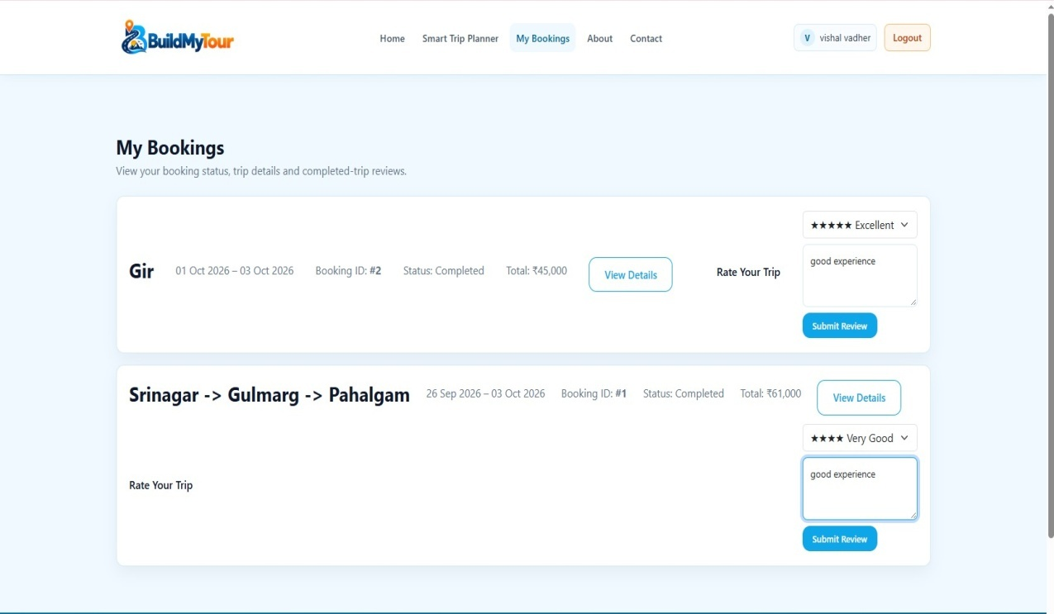

Figure 17: BuildMyTour – Admin Login
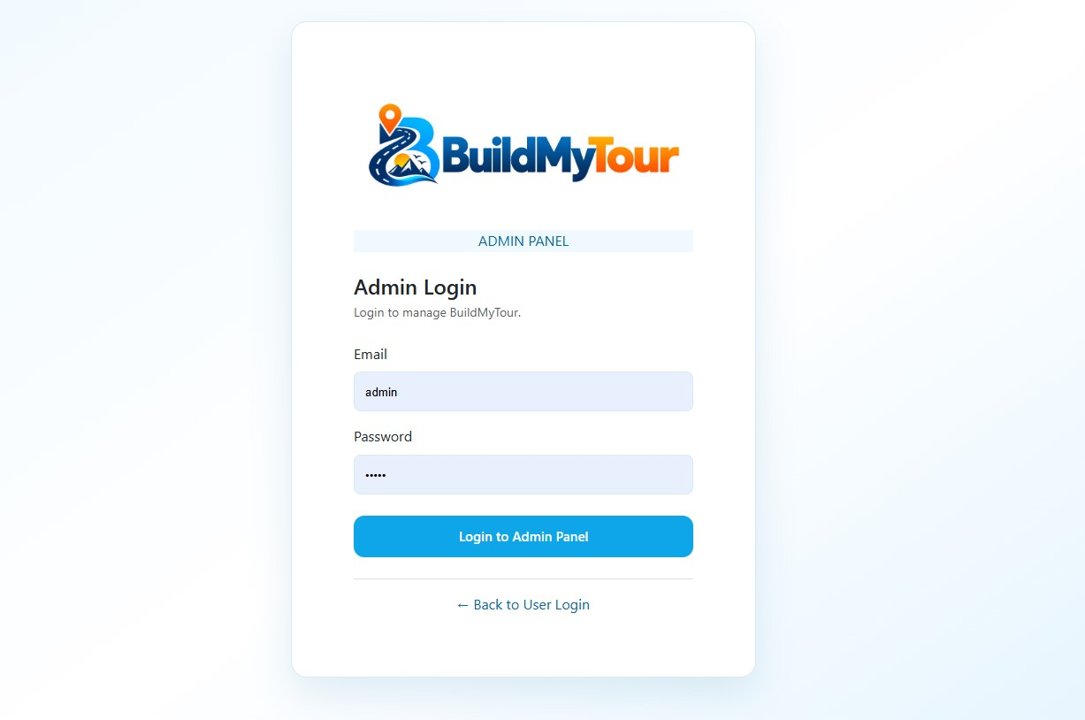

Figure 18: BuildMyTour – Admin Dashboard
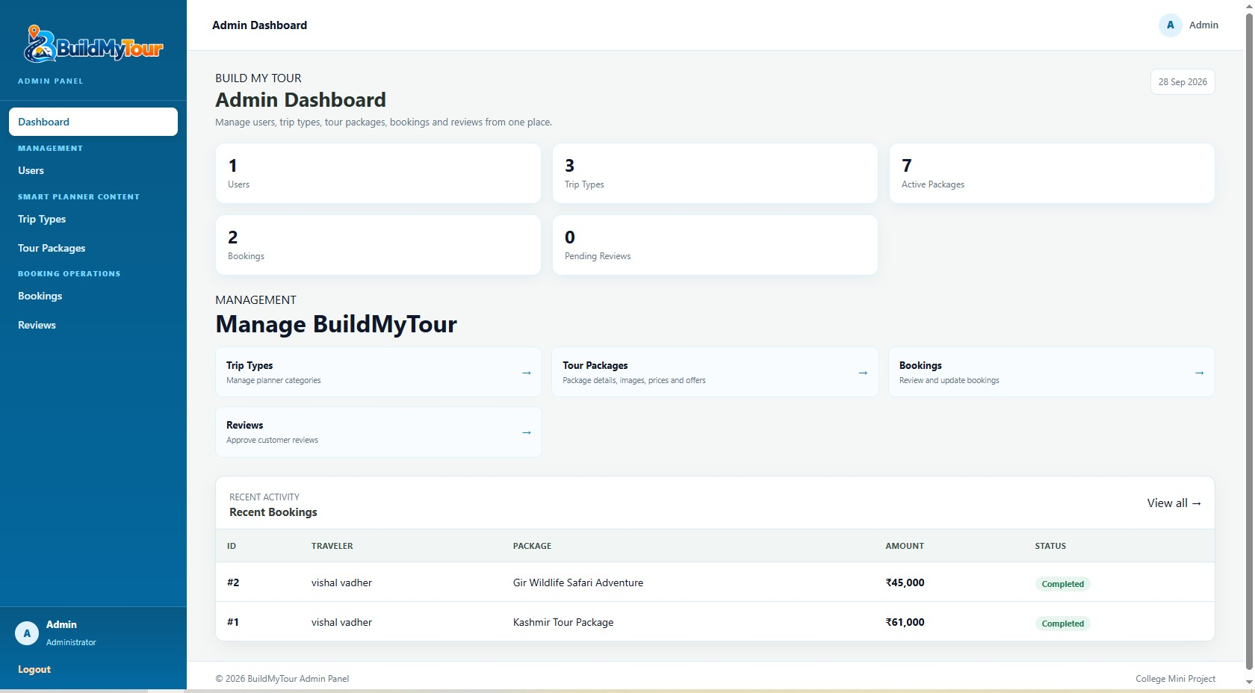

Figure 19: BuildMyTour – User Management
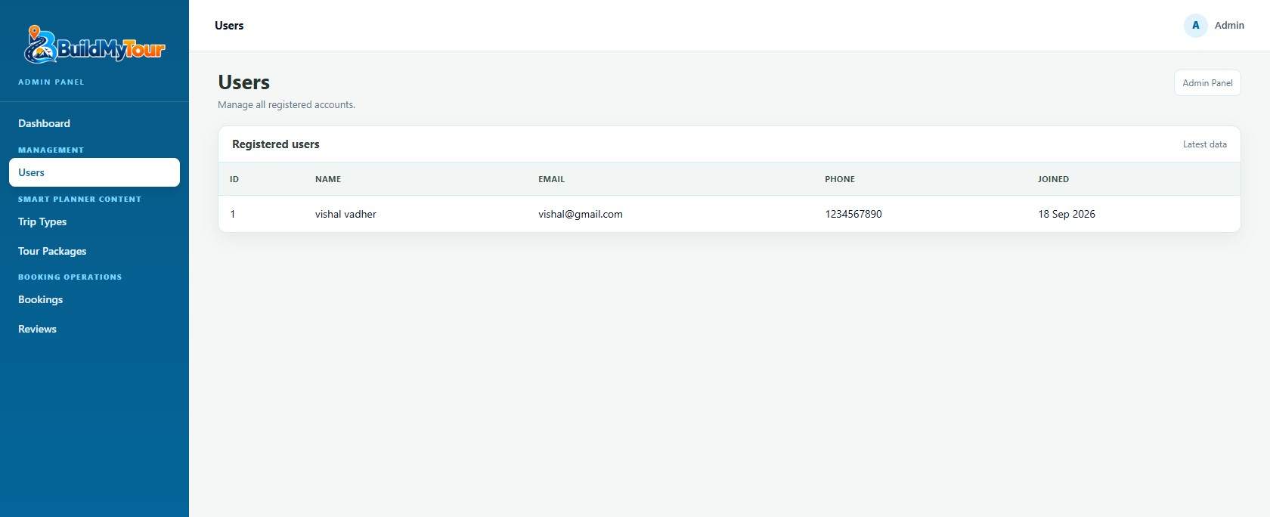

Figure 20: BuildMyTour – Trip Categories
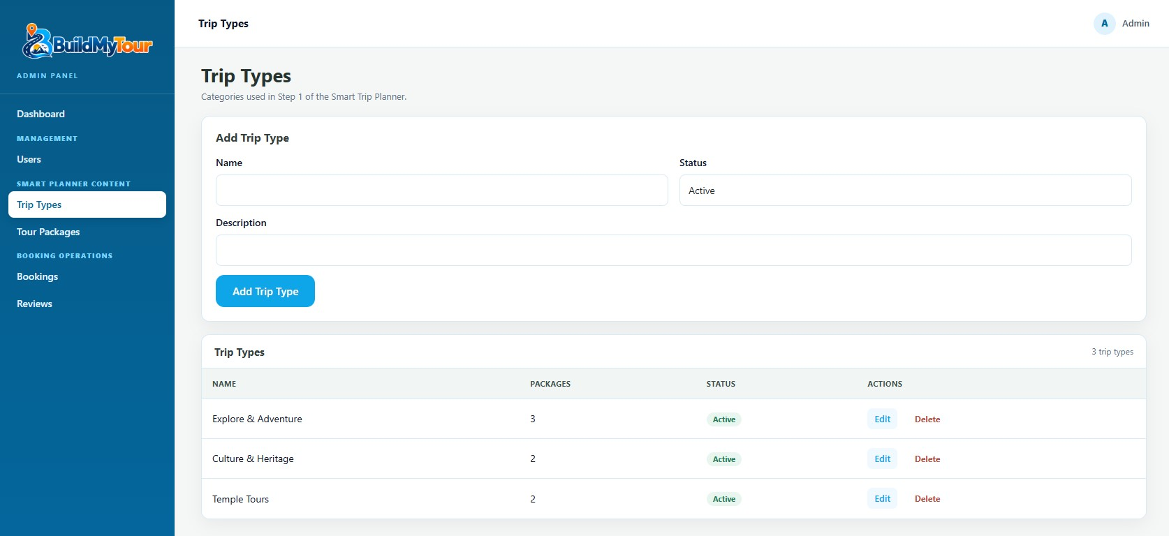

Figure 21: BuildMyTour – Tour Packages Management
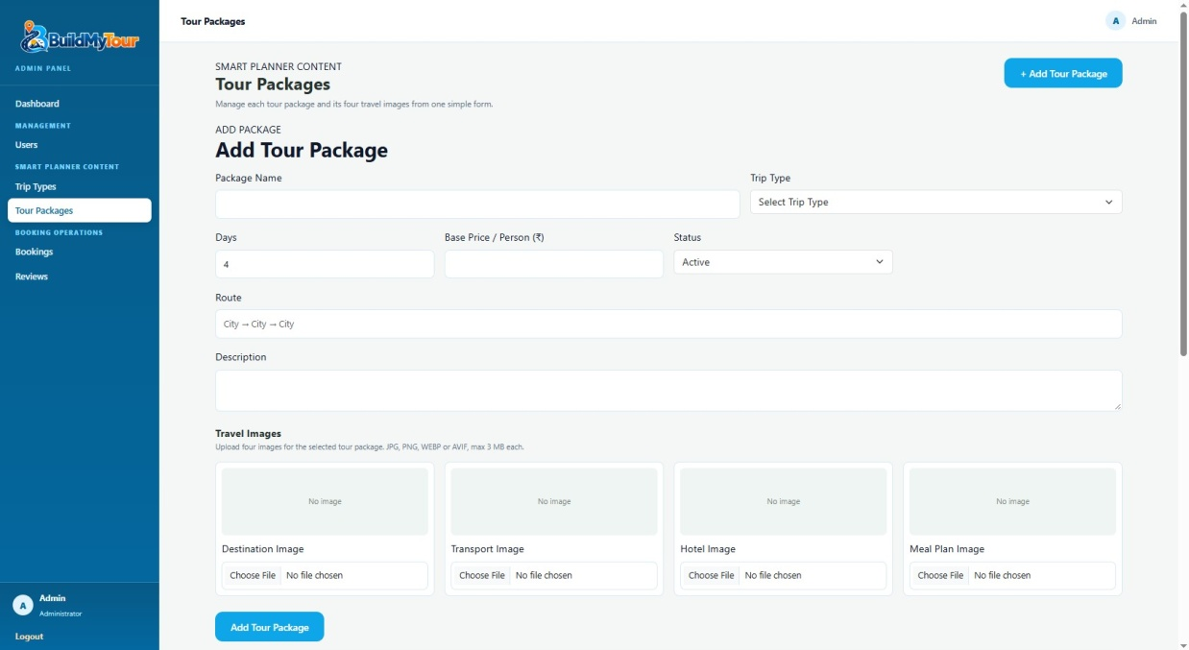

Figure 23: BuildMyTour – Trip & Booking Management
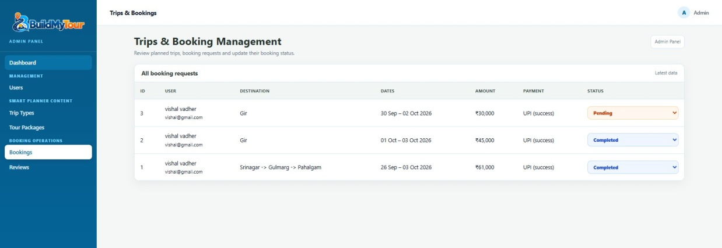

Figure 24: BuildMyTour – Reviews Management
